Instructions on NIST validation Tool:

- Please click on ISDH Meaningful Use website link: http://www.meaningfuluse.isdh.in.gov/
- See Quick links to NIST Testing tools on MU website (see below screenshots for next steps).
- Please use the ELR and Syndromic NIST HL7 2.5.1 Validation tool to run only the test patient data. (see below note**)

**Note: Due to patient confidentiality issues (e.g., HIPPA requirements regarding PHI), this software should not be used via the NIST Website for validation of messages containing real patient information. You may download this software on your local machine to validate messages contacting real patient data (see installation instructions on NIST website).

- Please email few downloaded NIST reports to isdhelrss@isdh.IN.gov, once you have the NIST errors down to less than ten errors on ELR and less than five errors on Syndromic Surveillance (PHESS).
- ISDH would like to see error free NIST reports to move to next round of testing. We don’t get ISDH resources involved for some preliminary feedback until you have a minimal number of NIST errors (less than ten errors on ELR and less than five errors on Syndromic Surveillance).

Step 1: Please click on the link NIST (National Institute of Standards and Technology) Testing Tools

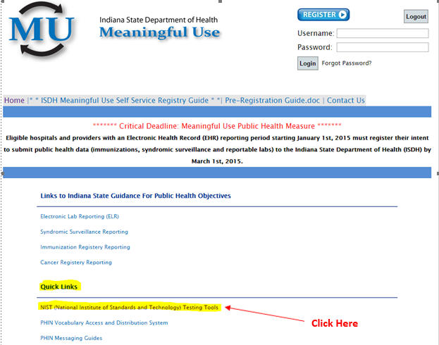
Step 2:

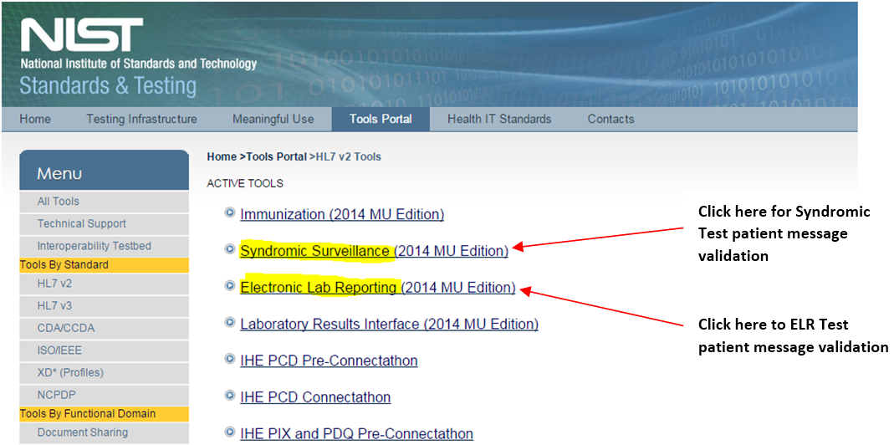

- For PHESS (Syndromic Surveillance):
Step 3:

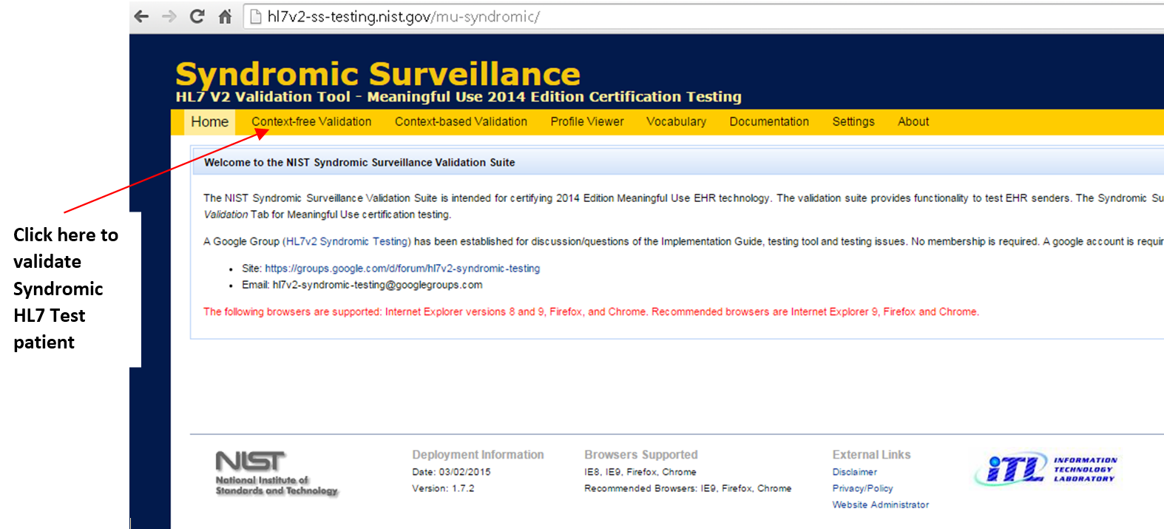

Step 4: Please follow the steps highlighted in RED

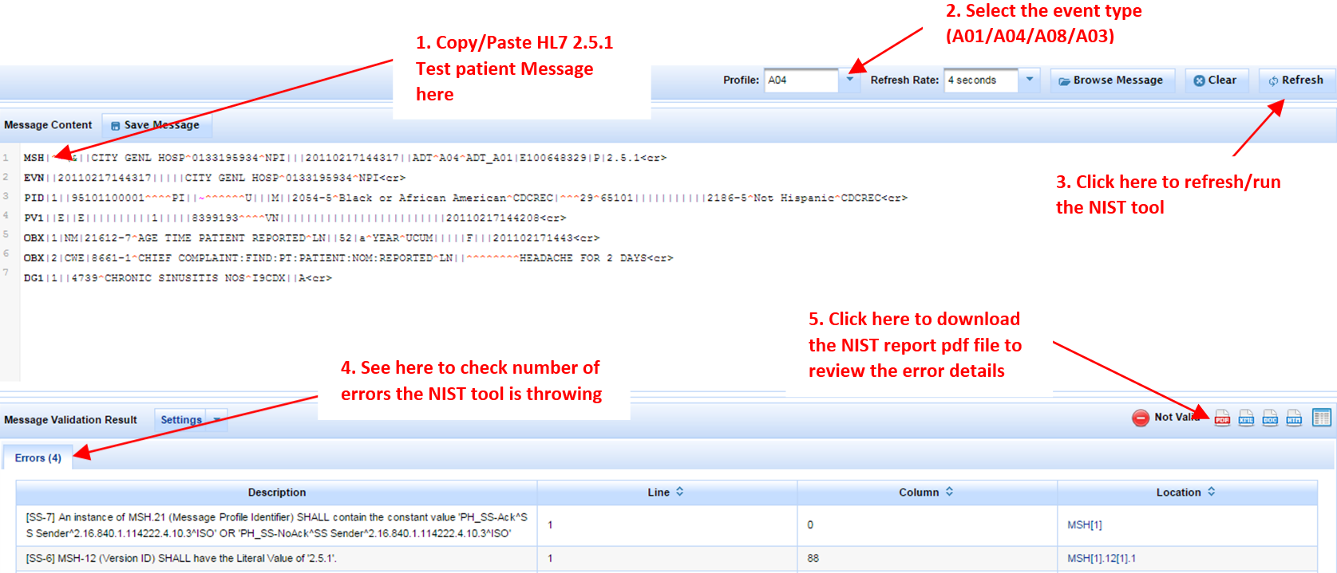

- For ELR:
Step 3:

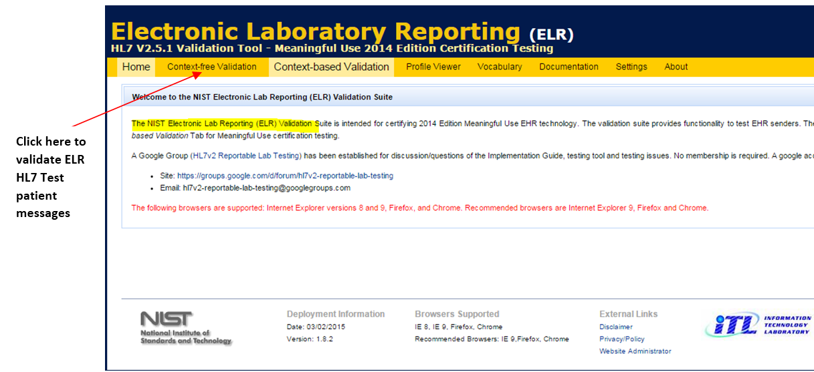

Step 4: Please follow the steps highlighted in RED



